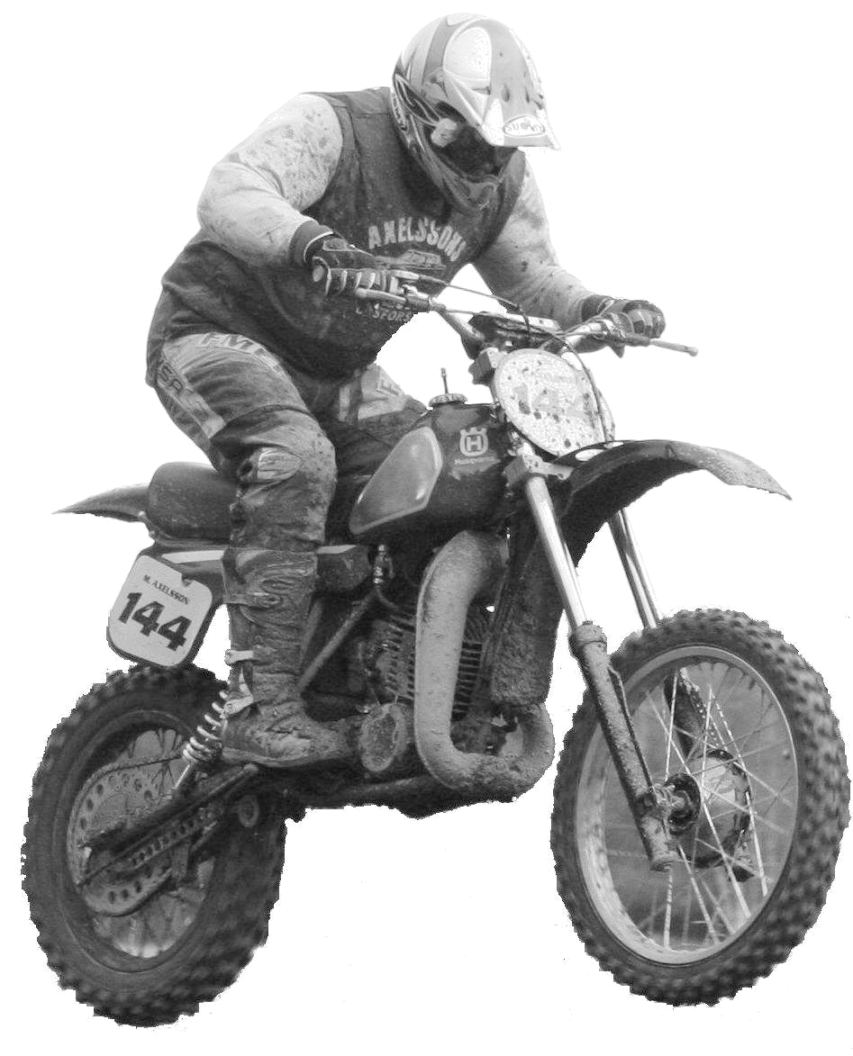

ENTRY FORM
Twin Shock Cup
Twin Shock Cup
TSC-1

Twin Shock Cup

Neiden-Germany
02 - 05 - 2009

Please use blockletters

Name
1st name
Street and nr.
Zipcode
City
Country
Date of birth
Phone nr.
Fax nr.
E-mail address
License Number
Transponder | Make: |  | Number:

Brand of bike | Year of building

Send the entry-form before 02-04-2009 to e-mail: djfm.fg@online.de

By Fax or letter, see below

For further information :
Frieshelm Gartzert  Konrad Adenauerstr.7  57572 Niederfischbach  Germany | Phone: +49 2734 61952  Fax : +49 2734 61952  Mail : djfm.fg@online.de

