ENTRY FORM
TSC-3

Twin Shock Cup

Hadsund - Denmark
15 - 08 - 2009
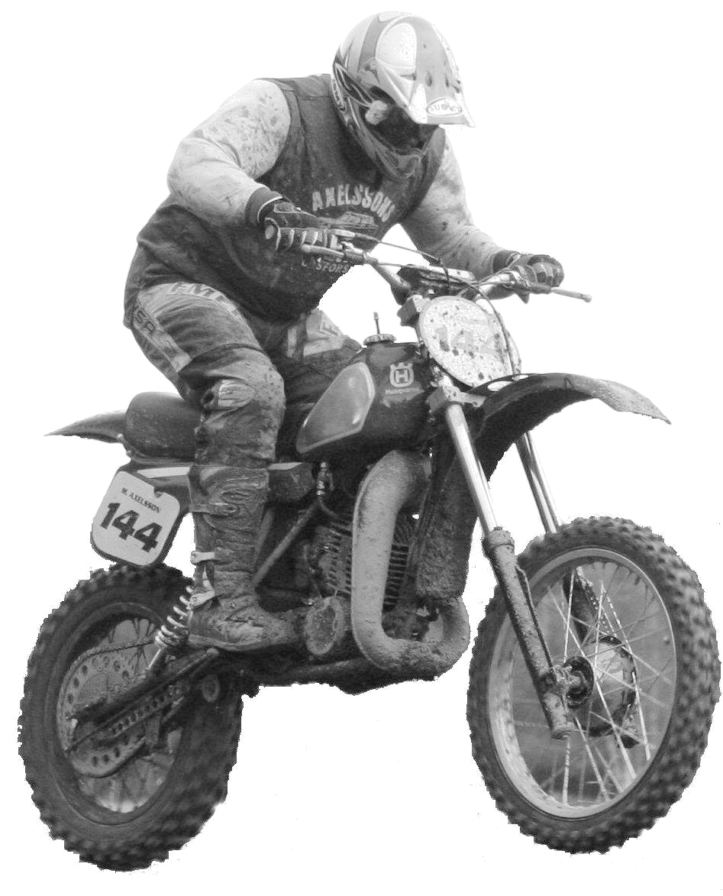

Twin Shock Cup
Twin Shock Cup

Please use blockletters

Name
1st name
Street and nr.
Zipcode
City
Country
Date of birth
Phone nr.
Fax nr.
E-mail address
License Number
Transponder | Make: |  | Number:

Brand of bike | Year of building

Send the entry-form before 15-07-2009 to NEMKA@Mail.dk or to havndal.elservice@yahoo.dk

By Fax or letter, see below

For further information
Niels Erik Mogensen,  Borgervej 11,  9500 Hobro, Denmark. | Phone: +45 967 293 00, mobil: +45 406 073 17  Fax : +45 981 333 38  Mail : NEMKA@Mail.dk
Or:
Martin Pedersen,  Østerbro 24,  8970 Havndal, Denmark. | Phone: +45 864 700 32, mobil: +45 402 756 32  Fax : +45 981 333 38 (same as above)  Mail : havndal.elservice@yahoo.dk
Address to the Race track  Hadsund Motor Club.  Ålborgvej 64,  9560 Hadsund (Jylland)  Denmark | The Hadsund track is located about 30km.  north of Mosten MC/Ørsted, where the  OLT-2 is run June 6, this year.

