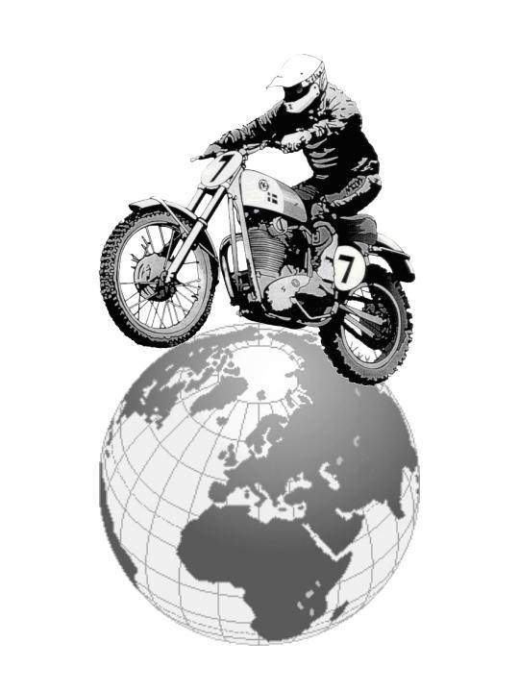
OLT Champions 2008
Ove Lundell Trophy
Ove Lundell Trophy

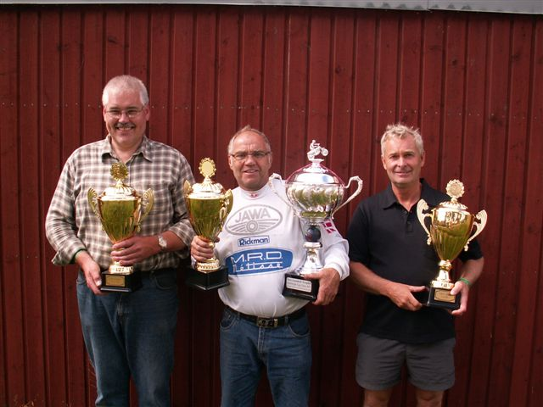
-50 Mogens Jensen, DK 60+ Bendt Preus, DK 50+ Sölve Linderson, SE

Bendt Preus won the OLT 60+ class for the second time. 2008 he made the first inscription in Karin and Christer Garver’s Challenge Cup for the 60+ class.

Champion 60+ (centre)

Bendt Preus
Lives in Vejby on the island Sjælland in Denmark. Family is Birthe and the children Susanne (45), Martin (37) and Nils (37). Bendt is retired. His profession was Car dealer/Repair shop.

His life is now the family and Classic Motocross. He has been riding ”modern” Motocross races in the years 1969-1976, Old Boys Motocross 1977-1994 and since 1995 he now rides Classic Motocross with his Jawa/Metisse.

Bendt has started to build a summer house for his family, so there will be less time for motocross next year, but he sais that he will definitely go for another inscription in the 60+ OLT Challenge Cup 2009!

Cont.

OLT Champions 2008
Ove Lundell Trophy
Ove Lundell Trophy

Champion 50+ (R.h. side)

Sölve Linderson, SE
Lives in Vimmerby, Sweden. Family is Gertrud and the children Patrik (39), Edvard (34) and Annie (29).

Sölve is running a business in the Construction branch.
He is also active on the race organization side, and was the clerk of the course for the CMCdN in Vimmerby, SE, 2007!

He started his modern motocross carrier 1968 on a 2-stroke Husqvarna and continued until 1975. During this time he was District Junior Champion for three years and after that he continued in the senior class. During this time he also qualified to participate in the Swedish Champion ship.

Except for the ESO/Wasp bike Sölve has a Husaberg 450 for practicing.

Sölve, 59 years old now, is looking forward to the OLT races next year in the 60+ class and hopes to be able to continue riding Classic Motocross for many years still!

Champion – 50 (L.h. side)

Mogens Jensen, DK
Mogens lives on a farm in Gelsted on the island Fyn in Denmark. The favorite building on the farm is the work shop where he can work on his motorbike.

His profession is machine mechanic.

Mogens has been riding motocross since 1986. The motor bikes were Husqvarna 2- and 4-stroke machines in the beginning. The last 5 years he has been riding classic motocross on his SOH Jawa.

Riding off road on his mountain bike is the main medicine to keep him fit to ride motocross.
Other interests are restoration of old farming machines.

2008-08-04
C. Garver

